

FIESA: the beauty store

Online shop retail price

**TRAINER NAME: Lavish Arora**

**PREPARED BY: “group 7”**

**Anushka Bajpai (7084001125) (anushka55555bajpai@gmail.com)**

**Shubhangi Singh [(8005452612) (30shubhusingh@gmail.com)](mailto:(8005452612)(30shubhusingh@gmail.com))**

**Shruti Gupta (8178698707) (shutkirti019@gmail.com)**

**Ruchi (9457721727) (ruchi13gr@gmail.com)**

**(BTECH 1st year)**

INDERPRASTHA ENGINEERING COLLEGE

ghaziabad

1. **OBJECTIVE**

**Here along the world , we stand for your beautification..Enhancing your spirit by decorating your outer appearance…Standing out, we at FIESA allow you to gain confidence and show what we got…with unbeatable prices and beautification mode on we bring you love, care, confidence and BEAUTY…..**

**This is a grp project of 1st year students of INDERPRASTHA ENGINEERING COLLEGE,GHAZIABAD.**

**We designed to make costumers feel happy with the appearance and variety..**

1. **BUSINESS SCENARIO**

**Today in the business world, we try to stand and make our own presence and importance. our site shows what kind of companies we deal with , what products we offer….for further details we have a contact no. and email that’ll take you to our costumer care. We help to make sure the costumer is treated at first..**

1. **CHALLENGES**

* **To facilitate our customers.**
* **To give products as fast as we can**
* **To allow costumer to see what are latest trends and products.**

1. **RESULT**

**A online cosmetic shop is always in demand ..these sites give you freedom to choose among many.**

**This is used and developed every other time…**

**Html css webpage is completed with certain issues . Verified by trainer.**

1. **IMAGES**

**Frontpage**

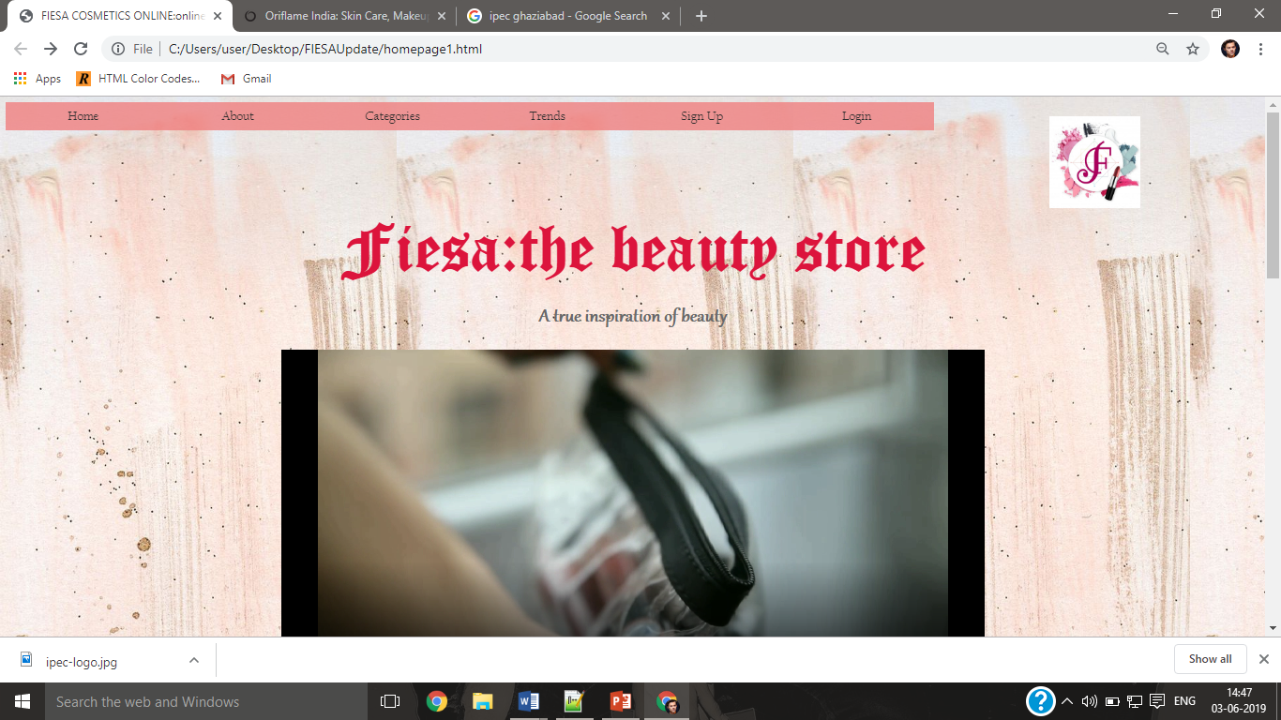

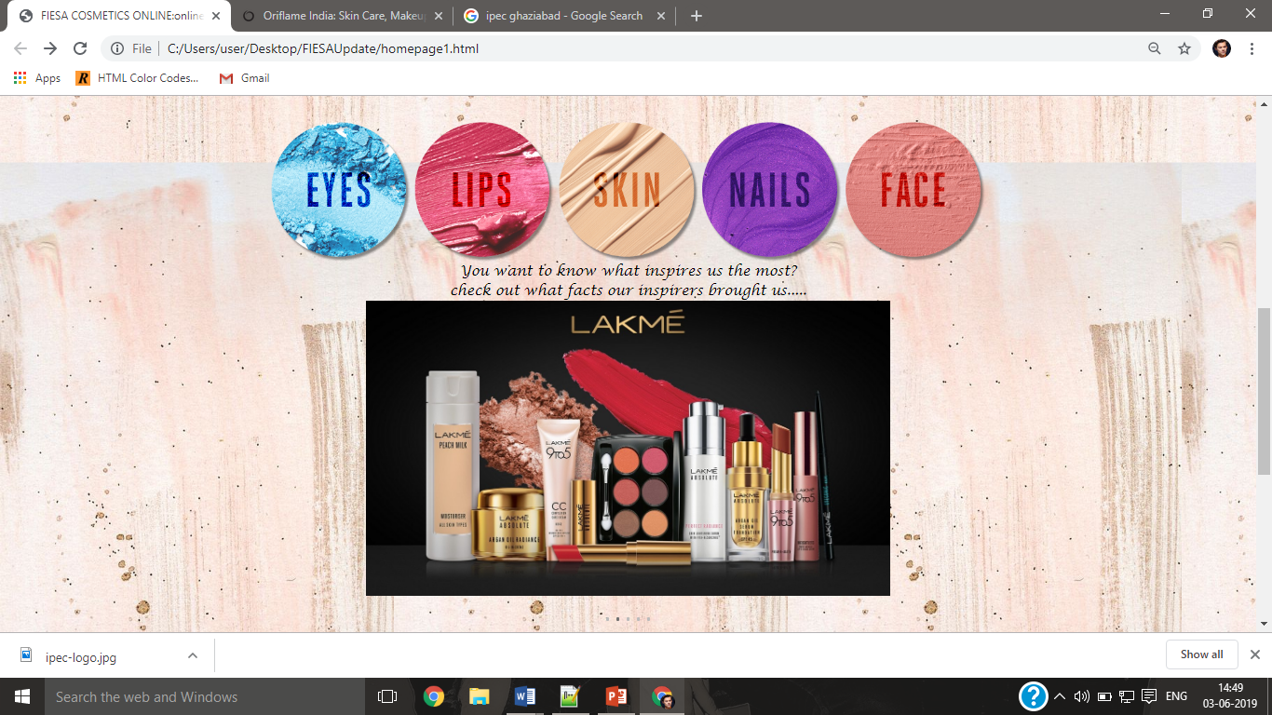

Eyes page

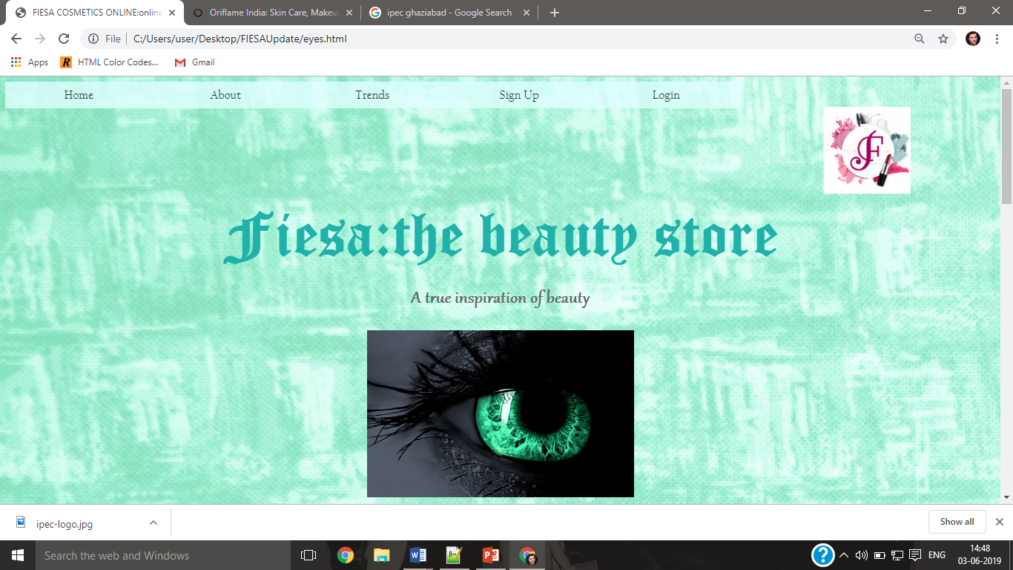

Lips

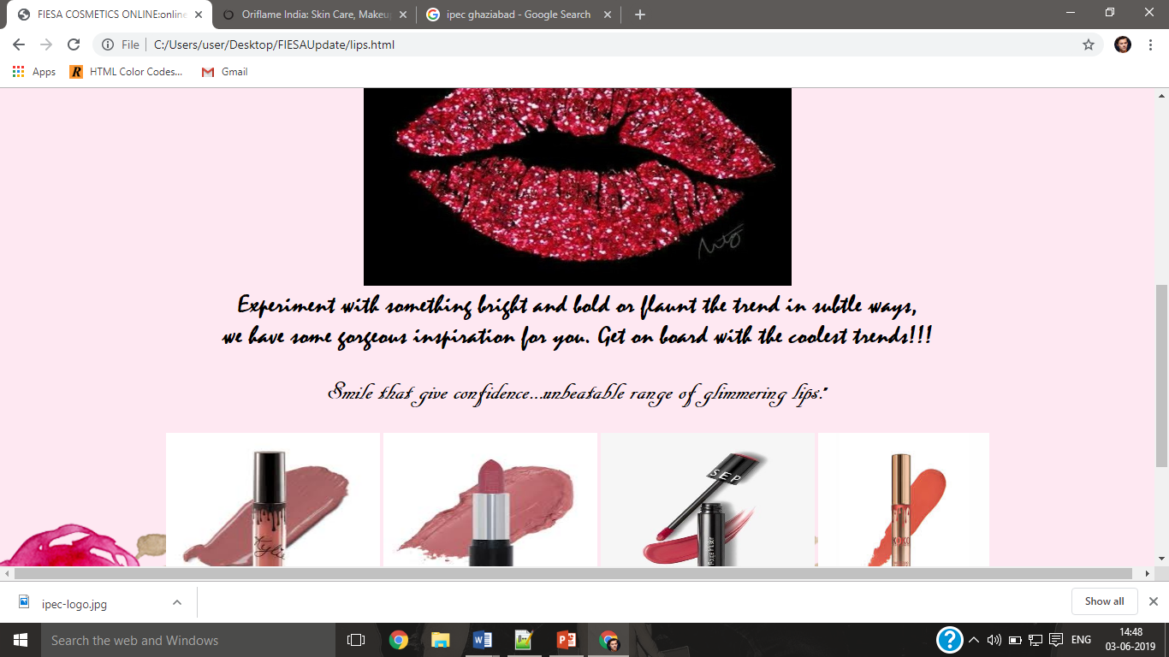

Skin

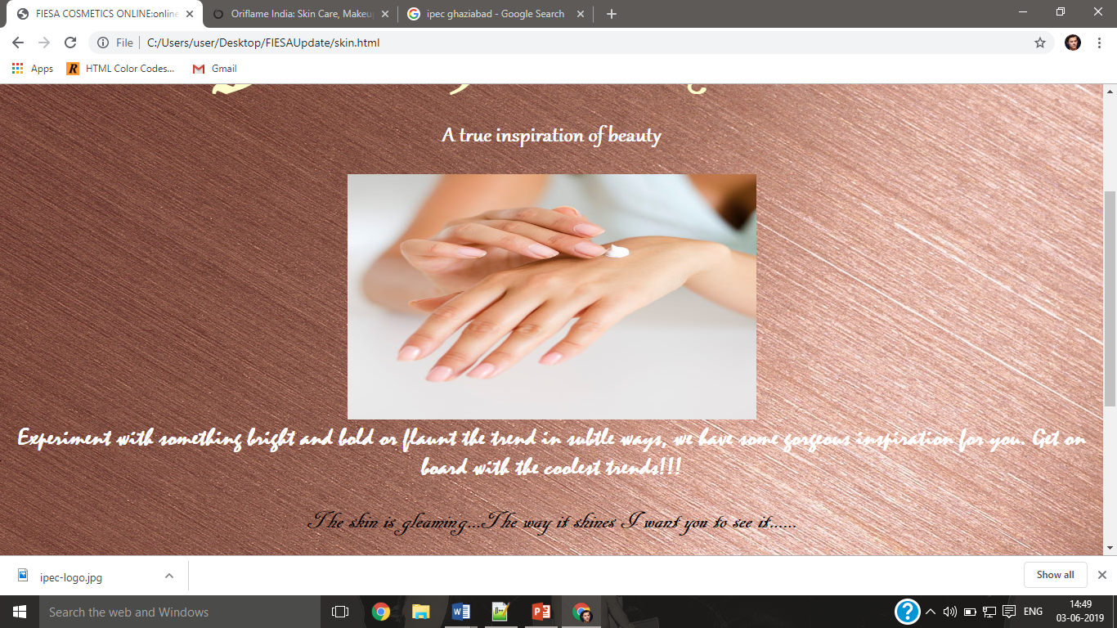

Nails

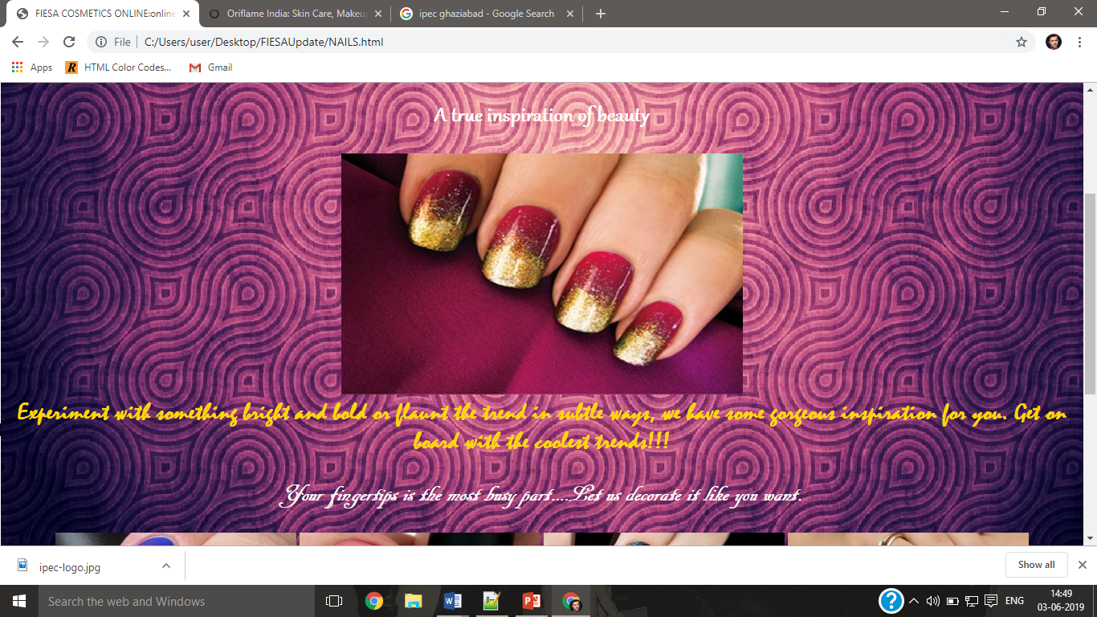

Face

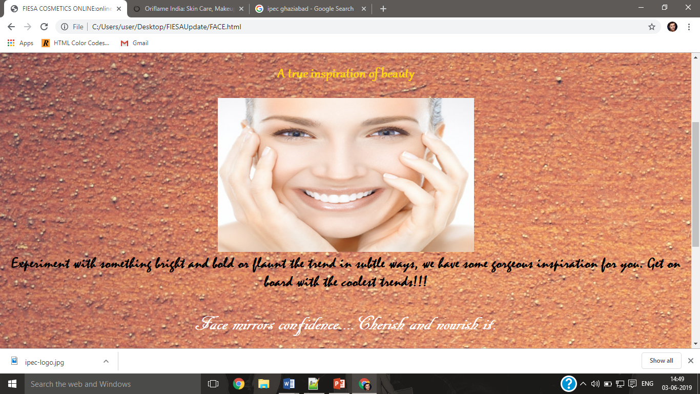

Signup

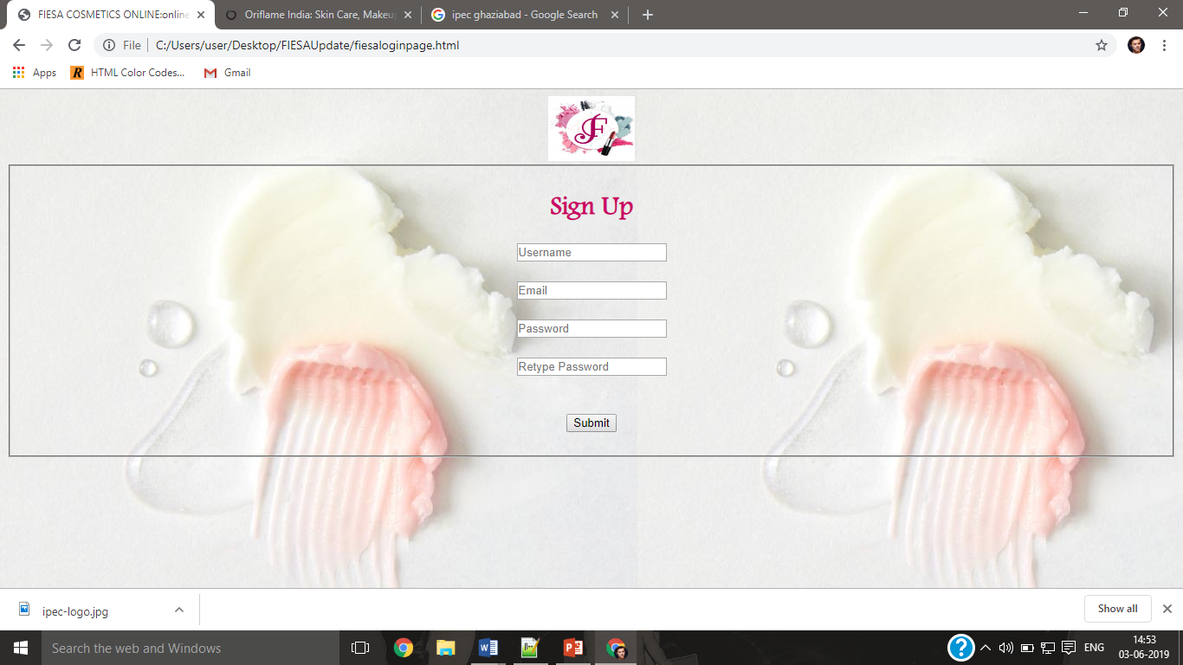

Login

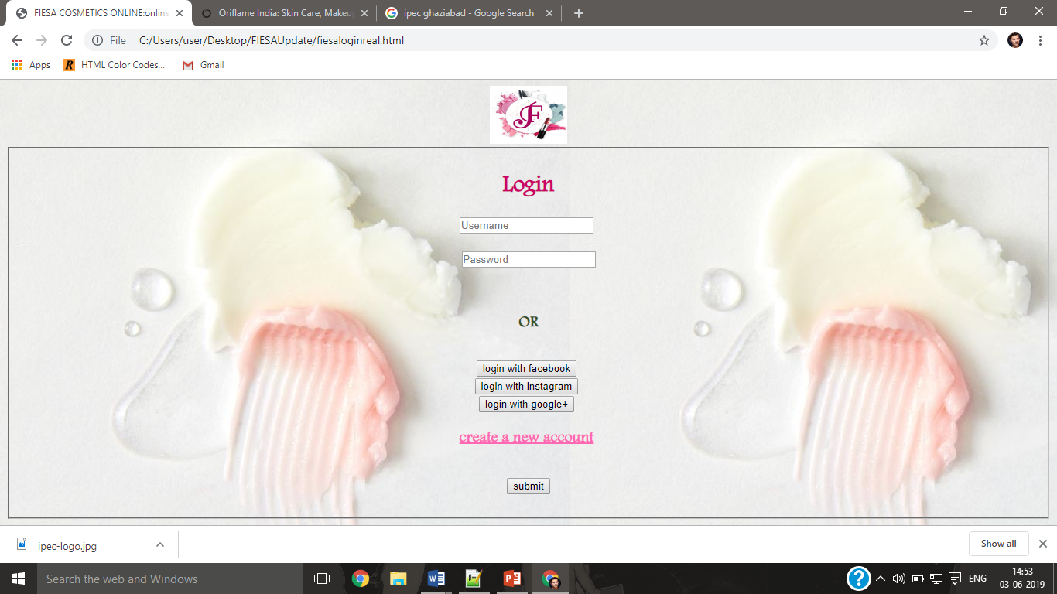

Feedback

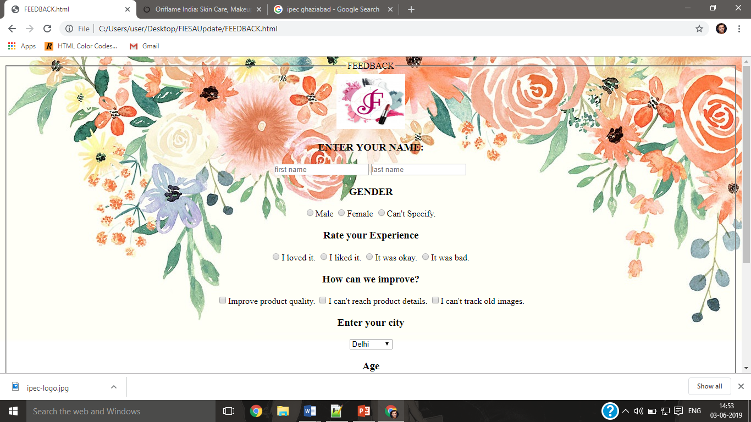

GROUP PARTICIPENTS :

ANUSHKA BAJPAI

SHUBHANGI SINGH

SHRUTI GUPTA

RUCHI